PHYS 212 PreLab 9 Name ______________ ID_____________________
Polarization
Q1[8’] If we start out with plane-polarized light with intensity I₀, with its plane of polarization at 30° to the horizontal, what will be the intensity after it is passed through a horizontal polarizer?[4’] What is the state of polarization?[4’]
_________________________________________________________
_________________________________________________________

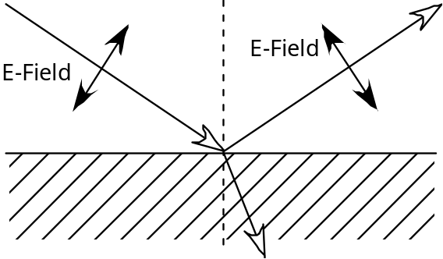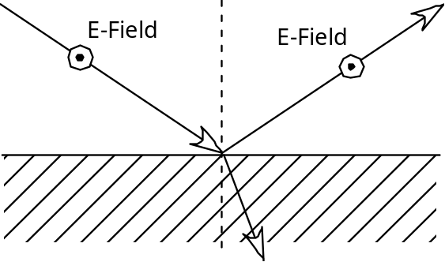
“Parallel” polarization “Perpendicular” polarization
Figure 1. E-fields for parallel and perpendicular polarizations

Consider the electric fields of the two possible polarization states (parallel and perpendicular) in Figure 1. Draw in the oscillation directions of the electrons in the interface due to the transmitted light (the oscillation for the incident and reflected beams has already been drawn for you).

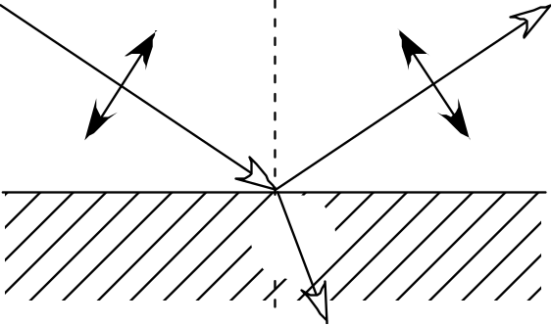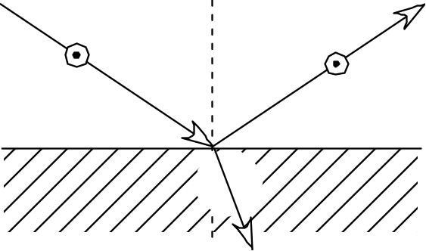

Q2[8’] For which case above are the electrons more likely to radiate light into the reflected beam?
_________________________________________________________

Q3[8’] If you wanted to reduce glare off a lake, or the hood of a car, how should the polarizers in your sunglasses be oriented?
_________________________________________________________
_________________________________________________________
Note that this same explanation predicts that the sky should appear polarized. In this case the light is “reflected” off the molecules in the atmosphere.

Q4[8’] Assume you are looking up at the sky, with the sun behind you as shown in the sketch below. Which way will the sky be polarized? [Note: Honeybees use this fact to navigate!]
_________________________________________________________
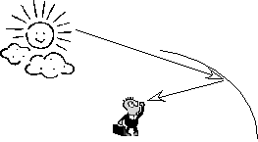
Figure 2. Sketch of light scattering off sky.
The three ways to change polarization that we’ve studied so far (polarizers, angled-reflection off an interface, and scattering off small particles) all change the polarization by absorbing or scattering away one component of polarization. We can also use birefringence to change polarization without loss.

Q5[8’] Is the index of refraction greater for the “slow” polarization component or the “fast” polarization component?
__________________________________________________________
In most materials the index of refraction does not depend on polarization. However, in every material the index does depend on the frequency of the light, a phenomenon known as “dispersion”.
On the diagram of a triangular prism below, sketch the approximate trajectory for violet light. Now sketch the trajectory for red light (clearly indicating which is which). You need to know that in glass, the index of refraction for violet light is slightly larger (n = 1.52) than the index of refraction for red light (1.51).

Beam of White Light
Glass Prism

Dispersion
In most materials the index of refraction does not depend on polarization. However, in every material the index does depend on the frequency of the light, a phenomenon known as “dispersion”.
On the diagram of a triangular prism below, sketch the approximate trajectory for violet light. Now sketch the trajectory for red light (clearly indicating which is which). You need to know that in glass, the index of refraction for violet light is slightly larger (n = 1.52) than the index of refraction for red light (1.51).

Beam of White Light
Glass Prism

Q6[2’] A physics student with hyperopia is having a terrible time reading her assignment, because it is too close and all she can see is a blur. But, she remembers that lenses can form images of objects, and that if she could just "move" the image of her assignment to another point, she could read it much more easily. Should she move the image closer to or farther away from her eye?
___________________________________________________________
___________________________________________________________

Q7[3’] What is the image distance q? Remember that q in this case corresponds to the closest distance the image can be to the hyperopic eye and still remain focused. Also note that the value of q must be negative, because an image appearing on the side of the lens where light also enters the lens is considered to be a negative distance from that lens.

q = ___________________ [m]
Q8[3’] Given the values for p and q above, what is the focal length of the needed lens?

f = ___________________ [m]
Since optometrists do not deal in focal lengths, we cannot make a prescription yet. However, we can convert the focal length, measured in meters, to a "power," measured in diopters, which is what optometrists use.
The power of a lens is defined as
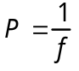 (Eq. 2)
where P is the power, measured in diopters, and f is the focal length, measured in meters. Diopters are symbolized by D.
Q9[2’] What is the power, expressed in units of diopters, of the needed lens?

P = ___________________ [D]

